create table expense

( orderid number(5),

providerid number(5),

providername varchar2(20),

amount number (7,2),

orderdate date);

insert into expense values(11236,501,'walmart',45450.56,'22-jan-16');

select \* from expense;

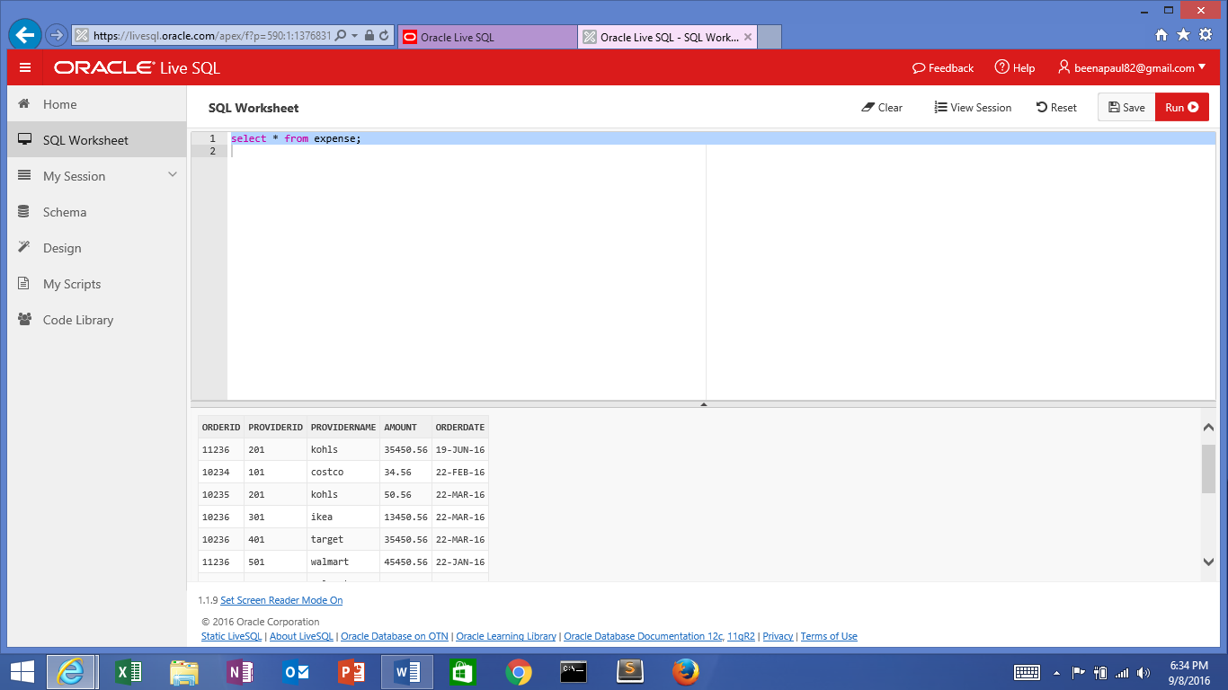

Select providername from expense

Group by providerid

Having sum(amount) > 30000;

Select \* from expense where providername = ‘amazon’;